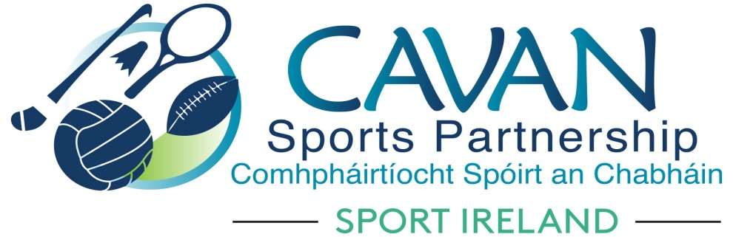

Annual Report 2018

‘Sport and activity for life, for all’

Contents

Page

Foreward ................................................................................ 3

Introduction ................................................................................ 5

CSP board & staff ................................................................................ 6

CSP Funding ................................................................................ 8

CSP vision, mission & values ................................................................... 10

Cavan Sports Partnership 2018 Highlights................................................. 12

Annual Reporting Data 2018 ................................................................... 15
Governance ........................................................................................... 23

Conclusion ............................................................................................ 24

Appendix …………………………………………………………………………………………….. 25

Foreword

On behalf of Cavan Sports Partnership, we are delighted to present this annual report, which provides an overview of the work of the Partnership in 2018.
CSP continues to be very thankful to Cavan County Council, Sport Ireland and our local partners for their continued support and investment which enables us to do our job.
Finally, CSP thanks all those who have contributed to the compilation of this annual report and also to the team of tutors who were involved in the many programmes. A special word of thanks must go to the staff of CSP who work hard to ensure we meet our strategic objectives each year.

John Kearney Nadine Mc Cormilla

Chairperson Sports Co-ordinator

Cavan Sports Partnership, summary 2018
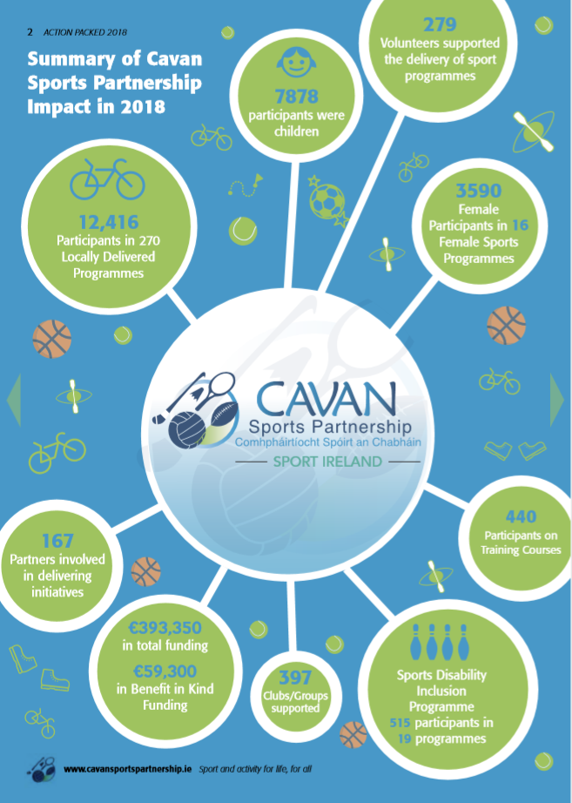

Introduction
Sport Ireland (formerly The Irish Sports Council) was established in 1999 to plan, lead and coordinate the sustainable development of sport in Ireland. In its first strategic plan (2000) Sport Ireland proposed the creation of a network of Local Sports Partnerships (LSPs) as a central element in advancing its Participation Strategy. By 2008, a national network of 30 LSPs had been established, including Cavan Sports Partnership (CSP). The key role of the Local Sports Partnerships was and is to increase participation in sport by creating sustainable structures for people to become involved at a level of their choosing, regardless of their ability, gender or background.
On the ground, Cavan Sports Partnership operates as a substructure of Cavan County Council, guided by a Board comprised of key local stakeholders and influencers in sport and activity. The CSP and its associated staff are housed within the Community and Enterprise Section of the Council and the development of sports and activity within the county and the work of the CSP are prominent within the Local Economic and Community Plan (2016-2021). Fundamental to the operation and success of the Sports Partnership is ongoing collaboration with partners throughout the county and beyond, including local sports clubs and communities, National Governing Bodies of Sport, statutory agencies, sports providers including coaches and trainers, target group networks, volunteers and the wider community.
2018 saw the much awaited launch of the Department of Transport, Tourism and Sport’s ‘ National sports policy 2018 – 2027’. The vision of the National sports policy is that people will be inspired, their lives enriched, their enjoyment enhanced and their quality of life improved as a result of their own active or social participation in sport. The local sports partnerships are central to the achievement of the DTTAS vision for sports participation in Ireland.

Who are we?

Cavan Sports Partnership Staff 2017
Sports Coordinator; Nadine Mc Cormilla
Sports Administrator; Regina Duffy
Sports Inclusion Development Officer; Dean Mc Elroy
Community Sports Development Officer; Aine O Reilly
Sports Hub Development Officer; Blánaid Carney

The 2018 Board of Cavan Sports Partnership
An advisory board guides the work of the CSP and ensures effective implementation of the strategic plan. It is made up of those regarded as key influencers and stakeholders in local sports development and comprises of representatives of the following agencies, sporting and community organisations:
Cavan & Monaghan ETB; Breffni Integrated;
Cavan County Council; Health Service Executive;
Schools representatives; Public Participation Network;
Disability representative; Elected representatives;
Sports Representatives; Cavan Institute:

Role of the Cavan Sports Partnership
CSP has a role across the sports landscape of County Cavan including:
•Supporting facilities, organisations and volunteers which make sports possible, for example sports halls, pitches, sports clubs, youth and community groups, coaches and committees.
•Enabling sports activities which appeal to people and encourage participation, to include team sports, minority sports and individual sports.
•Providing access to information on the sports activities, opportunities and organisations which enable people to structure their participation in sports.

We will undertake this role by:
- Providing meaningful Sports and Physical Activity Programmes
- Targeting Low Involvement Groups and Individuals
- Identifying Appropriate Places for Participation
- Fostering Quality Provision of Sports and Physical Activity Experiences

CSP Funding 2018
Core funding for Cavan Sports Partnership is provided by Sport Ireland. In 2018 SI provided €145,759 for staff and administration costs ( Co-ordinator, Administrator, Community Sports Development Officer) and a further €11,553 in programme funding for high priority targeted initiatives which are identified by CSP.
In addition to this Sport Ireland provided
- €35,000 toward the staff and administration costs of the Sports Inclusion Development Programme for Cavan & Monaghan. Additional staff and administrative costs were provided by Cavan County Council & Monaghan County Council.
- Additional staff and administrative costs for the Community Sports Development Officer were provided by Cavan County Council.
- €8,000 to host a ‘Be Active’ European Night of Sport
- Dormant accounts funding totalling €100,095 towards the following:
- Kilnaleck activity Hub phase 2
- Belturbet Activity Hub phase 1
- Sports leadership programme
- Coach & Volunteer Education programme
- Sports Inclusion capital development – Derryham Stables Sensory Trail

CSP was further funded by the following:
- Cavan County Council as a primary source of funding through “in kind” support such as office space and administrative support. Cavan County Council also provided support funding for the Cavan Walking festival events.
- Local partners who provide both financial and “in kind” support for CSP programmes such as venues, access to coaches and supported the administration aspect of programmes.
- Additional programme funding in 2018 was awarded from the following external sources:

Cavan County Council | €20,000
Go for Life | €1,100
National Bike Week | €3,522.80
Waterways Ireland | €2,000
Get Ireland Working | €800
Total | €27,422.80

CSP Programme Income:
CSP generated €36,894.57 in the form of programme/course fee receipts in 2018. These monies are redistributed throughout the work of the sports partnership and into the subsidising of future programmes across the county.

Cavan Sports Partnership ‘Sport and activity for life, for all’ 2017-2021
Cavan Sports Partnership has successfully delivered on year 2 of our current strategic plan ‘ Sport and activity for life, for all 2017-2021’.
Cavan Sports Partnerships third strategic plan ‘ Sport and activity for life, for all 2017-2021’ was developed and launched in 2017. This plan builds on the successes of the previous plans (Sport for life, Sport for All 2008 – 2012 and Sport for Life, Sport for All, 2013 – 2015) and has an aspiration of achieving an active county where sport and physical activity is an important part of daily life. This plan acknowledges the contribution that sport and physical activity has on not only the physical, but social and mental health of all people within our county.

Cavan Sports Partnership Vision, Mission and Values
The Vision of the Cavan Sports Partnership is very simple and reflects our determination to contribute towards improving the levels of sport and physical activity for all of the people in the county at all stages of life.

Our Vision: ‘Sport and activity for life, for all’

The Mission of the Cavan Sports Partnership is threefold:
- More activity throughout the county and more people taking part
- Support for and partnership with communities, clubs, sports providers and volunteers in the county
- Building Cavan’s sport and activity infrastructure and resource base

Cavan Sports Partnership Strategic Themes
The work of the CSP in the period 2017 to 2021 will be guided by the following three themes:
1. Building participation: continually improving the opportunities for all the people of the county to participate in sports or to be more active, with a particular focus on those with currently low participation rates.
2. Enhancing community capacity and partnerships: continually improving the human and physical resource base for sports and activity in Cavan and nurturing the relationships and collaborations which make things happen.
3. Improving Communications and Marketing: creating more awareness and understanding of the work of the CSP and consolidating its position as the information portal for sport and activity in Cavan.
The following Annual Report gives an overview of the work of Cavan Sports Partnership in 2017 under these three key strategic theme.

Cavan Sports Partnership 2018 Highlights
Sports Inclusion Programme
- In 2018 the Sports Inclusion programme provided 526 participation in sport and physical activity opportunities for people with a disability (367 adults, 159 children). A wide variety of programmes were delivered, from Jiving to Volleyball, to ensure all interests were facilitated at local level. Highlights include the Inclusive Horse Riding programme at Derryham Stables, which has since become an continuous fortnightly programme, with the facility also installing a Therapeutic Sensory Trail through Dormant Accounts 2018 fund.
- In September, a new Tennis initiative for children was delivered through Cavan Tennis club, which provided children with the opportunity to try a new activity while supporting a minority sport. Other local club highlights include rugby programmes with Cavan & Virginia RFC, a martial arts for adults with Black Dragon Club and Basketball with Cavan Lakers.

Older Adults
- In 2018, 579 people participated in Active Adult 50+ activities in Cavan, with activities ranging from Aerobics, Yoga Pilates, Dance and more.
- In April, a new Men on the Move was delivered, engaging 23 men through 3 activities, which has proven a challenge target group previously. Another highlight was the Physical Activity Leader Workshop delivered, with 12 new PALS being trained to provide their own groups with regular exercise.

Communities
- 2018 was a year with many highlights for Cavan Sports Partnership kicking it off with a Cavan Operation Transformation Leader and over 600 people taking part in 3 Operation Transformation Walks throughout the county. This was also the start of Cavan’s Community Transformation 6 week programme in 4 areas with over 355 starting out on their 2018 fitness journey.
- A busy January meant the commencing of a 10-week Community Coaching initiative with 6 coaches qualifying to coach 5 different sports and have continued to so resulting in a wide variety of sports delivered in primary schools throughout the county with over 3,300 children participating in a variety of sports such as Tug of War, Volleyball, little athletics, The Daily Mile and Tri-heroes.
- Spring 2018 welcomed the 8th year of the Cavan Walking festival hosting 19 community led walks and 810 walkers exploring the trails and woodlands of the county.
- Women on Water Kayaking initiative proved to be a big hit having to add a second programme with a total of 60 women taking part. This programme has now been continued by the local service provider themselves.
- Mothers and babies were kept active with a Buggy Bootcamp initiative ran in Cavan town and Virginia.
- Couch to 5k kept the activity levels up as 5 areas hosted the 5 week initiative throughout September with 140 people taking part.
- Cavan was chosen as one of five counties in the country to host a BEACTIVE NIGHT as part of the European week of sport initiative.

Schools
- Work in primary and secondary schools continued with two schools brochures produced offering a variety of coaching and training opportunities.
- 3,330 primary school students took part in CSP initiated programmes
- 3 secondary schools took part in CSP TY initiated programmes
Activity Hubs
- The Kilnaleck activity hub was launched in September 2018, a community based initiative funded through the dormant accounts fund with the overall objective of increasing participation in sport in rural communities.
- The Belturbet activity hub received funding in December 2018 through the dormant accounts fund.

Training & Education
- The training and education programme delivered safeguarding 1,2 &3 courses along with disability awareness, games for all, walking leader and first aid training to sports club coaches and volunteers throughout the county.

Healthy Cavan
- CSP signed up to the Healthy Cavan Framework as part of the healthy Ireland national initiative and was awarded funding for the delivery of
  - Cavan fit towns – community based physical activity initiative in communities of Kilnaleck, West Cavan, Virginia, Cavan Town & Cootehill.
  - Cavan fit schools – a ‘daily mile’ initiative targeting primary school children throughout the county.

National Initiatives
- CSP delivered the national initiatives; ‘bikeweek.ie,’ and ‘Get Ireland Walking’ in partnership with local clubs, agencies and community groups.

Annual reporting data 2018
The below data has been extracted by Sport Ireland from operational information submitted by Cavan Sports Partnership for 2018. CSP reported on programmes and participants interacting with actions in the 2018 operational plan. The following data represents the work throughout the year
Women in sport WIS
Cavan Sports Partnership signed up to the Federation of Irish Sports national campaign the ‘20x20’ initiative in 2018. 20×20 is about creating a cultural shift in our perception of girls and women in sport. By increasing visibility of women’s sport it will become a greater part of who we are and what we follow.
CSP aims to provide increased opportunities under the women in sport initiative for the girls and women in our county to become more involved in sport and physical activity at all levels.
In 2018 CSP received funding for 6 Women in Sport specific programmes with 172 women taking part.

Training and Education

The CARA Disability awareness training also proved popular. The dormant accounts funded ‘community coaching’ programme, in partnership with CMETB provided people who were not in full time employment with the skills to coach 5 sports in the school and club setting. The impact of this programme for schools in the county is evident in the school participation figures and has resulted in school aged children throughout the county receiving additional opportunities to take part in a variety of different sports.
Safeguarding
Sport Irelands programme targets sports leaders and adults involved in the organisation of sport for children and young people. Sport Ireland offers three workshops in the area of safeguarding and child protection.

 | No. of workshops delivered | No. of participants
Safeguarding 1 (Child welfare & protection basic awareness workshop) | 6 | 69
Safeguarding 2 (Club children’s officer) | 2 | 12
Safeguarding 3 (Designated liaison person) | 2 | 19

People with a disability

People with a disability are mainly targeted through day care service providers.
‘All people’ with a disability is made up of persons with a physical disability, sensory needs and people with poor mental health.

Age group focused initiatives

When breaking down the participants into age it is clear that the primary school setting had the largest numbers participating through a variety of initiatives. This is due to the success of the community coaching training programme and the 6 Cavan based schools coaches that were a result of this initiative and the opportunities this presented for schools.
The ‘Adult 22 -25’ number takes into account activities within the Kilnaleck Activity Hub, Couch to 5km, Women in Sport and Community Transformation programmes.
The balance bike ‘ wibbley wobbley ‘ programme proved a huge success with preschool services throughout the county. The programme, which is a partnership with Cavan County Childcare committee received funding from Healthy Cavan in addition to Sport Ireland funding.
Uptake by secondary schools for initiatives was poor in 2018. Feedback received indicated an already packed curriculum coupled with the varying needs of each individual school meant it was difficult for CSP to gain engagement across the county.

Participation initiatives
…..
The range of initiatives delivered in 2018 were dependant on a number of factors.
- Need expressed from target groups
- National programme delivery
- National and local policy delivery
- Partnership’s available to deliver on programmes
- Funding available
Participation initiatives generally ranged from 4 – 6 weeks with a number of national one day events happening throughout the year ie. Operation transformation.

The table above outlines the variety of sports delivered by CSP in partnership with NGB’s in 2018. These activities were delivered in local clubs, communities and schools.
Our strategic theme ‘Enhancing community capacity and partnerships’ outlined a number of objectives and actions to support NGB’s of sport and local sports clubs to build capacity locally. CSP engaged with 5 new NGB’s of sport – Basketball Ireland, Athletics Ireland, Triathlon Ireland, Volleyball Ireland, and the Irish Tug of War association in 2018. This partnership approach with each individual sporting body focused on capacity building and programme delivery locally.

CSP Small grant scheme recipients 2018
An allocation of €7,410 was disseminated to sports clubs and community groups. The aim of the grant scheme was to support club coaches and volunteers through training, education and equipment grants to resource and strengthen the club. A mass participation scheme also afforded both clubs and community groups the opportunity to gain financial support towards a community based sporting event.
 | Amount Awarded
Community Mass Participation | Total €1,500
Killeshandra GAA  Parkrun Ireland Ltd | € 500  € 1,000
Coach Education | Total €800
Cootehill Harps AFC  Cavan Triathlon Club  Belturbet Row Boat Club | € 300  € 200  € 300
Equipment | Total €5,110
Breffni Blues Special Olympics Club  CM Lakelands Feeder Angling Club  Drung Indoor Bowls Club  Cavan Down Syndrome  Cavan Taekwon Do  Co. Cavan Rugby Football Club  Cavan Wrestling Club  Templeport Ladies Football Club  Silver Finns Special Ability Swim Club  Bailieborough Tierworker Gun Club  Cavan Tennis and Pedal Club  Denn Gun Club  Killygarry Gun Club  Cavan Hockey Club  Butlersbridge LGFA  Erne Eagles Rounders Club  Cavan Lakers Basketball Club  Smugglers Cycling Club  Co Cavan Golf Club Ladies  Irish Wheelchair Association | € 300  € 300  € 200  € 260  € 300  € 300  € 300  € 200  € 300  € 150  € 300  € 150  € 150  € 300  € 200  € 200  € 300  € 300  € 300  € 300
Total | €7,410

Governance

In 2018 there was continued active participation of relevant agencies and partners on the CSP Board with 5 board meetings taking place throughout the year.

One grant sub-committee was formed and reported work to CSP Board;

Administrative and Financial Management:
Secure and manage the resources of the CSP in a transparent manner
- CSP input its data into a new Sport Ireland national monitoring and evaluation template for 2018.
- Bi annual financial reporting to Sport Ireland.
- Financial reporting to the board of the sports partnership.
- Internal auditing through Cavan County Council finance department.

Memberships:
- Federation of Irish Sport (FIS): CSP continued its annual membership of the Federation which advocates for sport at a national level.
- Member of the 2018 ‘20x20’ ‘ If she can’t see it she can’t be it’ national initiative to support increased participation of females in sport.
- CSP is also represented on a number of local committees ;
  - Cavan Age Friendly society, Cavan disability network, CYPSC Cavan, Healthy Cavan, Healthy Cavan at your library, ‘Right to read’ Cavan.

Conclusion
A noticeable increase in funding in 2018, from Sport Ireland and the Dormant Accounts fund is reflected in the increase in the overall number of programmes delivered and people participating in sport and physical activity throughout the county.
The continued investment both nationally and locally in both the community sports development officer and sports inclusion development officer has proved successful for participation in local communities, adults over 50+, people with disabilities and schools throughout the county. These dedicated resources have allowed the development of relationships and networks which in turn has strengthened community capacity to sustain physical activity programmes locally.
The dormant accounts funded community sport and activity hubs have given a new meaning to community sports development and have set a standard for CSP in terms of delivering similar models countywide. In 2017 we identified West Cavan as an area of improvement and we are delighted to have received additional funding from Sport Ireland through the dormant accounts fund 2018 for a sport and physical activity hub in Belturbet, Co. Cavan.
It is important to note that the key to the successful sport and physical activity hubs is the dedicated hub development officer who supports these communities in activating themselves to a healthier lifestyle. The sustainability of this development officer will be a key priority moving forward in our expansion of our hub model.
The partnership working between CSP and the National Governing Bodies of Sport (NGB’s) to provide participation opportunities within our schools and disability sports programmes in 2018 was an excellent example of how a LSP can support the national implementation of a local sport.
We recognise the need for a defined focus on the young people in our county and aim to work with both the school and out of school settings in delivering local initiatives to keep our young people involved in sport and physical activity.
We will continue to advocate for a full time sports inclusion development officer for Cavan, prioritising the needs of people with a disability and older adults in our County.
We will aim to focus more on CSP’s marketing and communications in 2018 while further implementing our strategic actions.
Appendix 1
Cavan Sports Partnership Board Members 2018
- Cavan & Monaghan ETB; Mr. John Kearny
- Breffni Integrated; Mr. Terry Hyland
- Cavan County Council; Mr. John Donohoe
- Health Service Executive; Mr. Colm Casey
- Cavan Institute; Mr. Enda O Reilly
- Schools representatives; Ms. Mary Mc Mullen
- Public Participation Network; Mr. Ronan Molloy
- Disability representative; Mr. David Cahill
- Elected representatives; Cllr. Paddy Mc Donald, Cllr. Madeline Argue, Cllr. Philip Brady
- Sporting Representatives: Mr. Liam Mc Cabe, Mr. Tom Downes, Ms Carol Kiernan, Mr. Brendan O’ Reilly.

