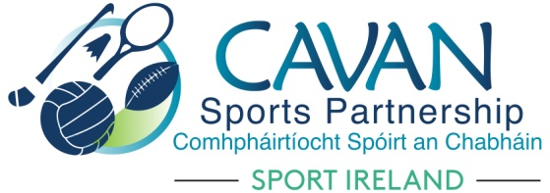

Call for expressions of interest
Cavan Sports Partnership is seeking expressions of Interest from sporting and community groups interested in establishing one of the following initiatives:
- Community Sports and physical activity Hub
- Urban outdoor adventure initiatives

The application process will have a number of stages
1) Submission of expression of interest form – Closing date 5pm Thursday 2nd September 2021
2) Attendance at an application support session workshop *compulsory – failure of a group to attend this support session will deem the expression of interest ineligible from the 2022 dormant accounts application process) – 7pm Monday 6th September 2021
3) Application submission to Cavan sports partnership – Wednesday 22nd September 2021
Application forms will then be reviewed by the finance & grant sub committee of Cavan Sports Partnership against set criteria in order to determine the project that will form an application to Sport Ireland. Cavan Sports Partnership will work with the selected community to refine the application in advance of submission to Sport Ireland.
Note: The application process to Sport Ireland is very competitive and there is no guarantee of funding.

- Community sports and physical activity hub
A Community Sports and Physical Activity Hub (Hub) is a collective of progressive sports clubs and other local organisations that want to work together to improve the sport offered in their local community. The Hubs will operate within the existing structures of the Local Sports Partnerships. The Hubs will provide information, support and advice on a wide range of sports and physical activities to make it easier for people in disadvantaged areas to get involved and engage in a more active and healthier lifestyle. The Hubs will recognise the diversity of their local communities and will seek to reach out and increase participation from all corners of the community. Each Hub will be unique, however they are all meant to work to certain principles, namely grow participation, engage the local community, promote community leadership, offer a range of sporting opportunities and bring all appropriate (key) partners/ groups/people together.
Duration: 5 year project commitment. Successful community sports hubs have the opportunity to avail of dormant account funding each year (amounts vary and are dependent on a successful application submission) for a 5 year period.
Funding
The range of funding investment for Community sports and physical activity hub initiatives by Sport Ireland through Dormant Accounts fund to successful sites is estimated at a maximum of €50,000 ( €25,000 current and €25,000 capital expenditure) per successful application with additional funding also available to the Local Sports Partnership to co-ordinate the project.

Vision and Mission of the Community Sports and Physical Activity Hubs:
Vision: The vision of a Hub is to increase the number of people of all ages participating in sport and physical activity in their communities.
Mission: The mission of the Community Sports and Physical Activity Hubs in disadvantaged areas is to bring local people together and provide a home for local clubs and sports organisations.
A Hub must be focused on one of the following themes:
1. Community Sports Hub This is a Hub where the community is at the heart and is centered around community participation. This includes developing and strengthening linkages between the community, sports clubs and other physical activity groups.
2. School Community Sports Hub This is a Hub that maximises sports facility usage through linkages with the local schools, community, sports clubs and other physical activity groups. 3. Outdoor Community Sports Hub This Hub will focus on the development of the outdoor space as a hub, increasing the linkages between the community, sports clubs and other physical activity groups.
Community Sports and Physical Activity Hubs can be either:
1. Area based : Maximise participation, improve the access to and usage of a range of existing facilities, enhance shared learning amongst the groups / clubs etc.
2. Site based:This is a focus on a center or a single-venue hosting many clubs. Maximise participation, improve the access to and usage of a facility, enhance shared learning amongst the groups / clubs etc.
Target Group: Hub applications must target people who are economically or socially disadvantaged, educationally disadvantages or who have a disability. Hubs which can evidence a focus on or are located in areas of deprivation according to the Pobal Deprivation Index will receive additional points in the assessment of applications.
Sustainability: Projects must demonstrate the ability to have a legacy potential once the Dormant Accounts Funding ceases.

2. Urban Outdoor Adventure Initiatives
There is now a growing body of evidence to suggest that outdoor adventure programmes, where participants interact with nature and experience new outdoor adventure sports, are successful in developing confidence and skills among participants, help young people to manage risk and encourages them to welcome challenging experiences. Opportunities for young people living in disadvantaged communities, those in the direct provision system, and those with a disability to experience outdoor adventure sports is limited due to natural environments, distance from traditional outdoor settings (forests, mountains etc.) where activities are usually offered, and the need for equipment, supervision, training and support to engage in these sports.
Vision and Mission of the Urban Outdoor Adventure Initiative
Vision: To increase the amount of people of all ages undertaking physical activity through outdoor activity and adventure sports living in urban environments.
Mission: To develop and promote opportunities for people to engage in outdoor activity and adventure sports in urban settings.
Duration: 12 months but has potential to develop into a longer term project such as a club or an outdoor hub

Funding
The range of funding investment for outdoor adventure hub initiatives by Sport Ireland through Dormant Accounts fund to successful sites is estimated at a maximum of €45,000 ( €30,000 current and €15,000 capital expenditure) per successful application.
Target Groups: The Urban Outdoor Adventure initiative must focus on disadvantaged communities, youth, people with a disability and /or women to be considered for support. Evidence of this will be required.

Outdoor activity and adventure sports includes all sport and recreation activities that can be undertaken in natural outdoor settings on land or water. Guidelines for initiatives :
- Will need to focus on creating sustainable opportunities for target groups to engage in outdoor activity and adventure sports that are possible to undertake in their locality.
- Can focus on one or a number of outdoor activity and adventure sports that can be undertaken in the town/city where the intervention is planned.
- Should be tailored around consultation with partners and participants and a review of outdoor recreation opportunities possible in the urban areas where the intervention is planned.
- Should involve partnership working with agencies including community groups, youth services, agencies, local clubs, schools, outdoor NGBs and others.
- May build on programmes that have been developed in the past. Should be completed within the timeframe of the programme.

Suggested outputs from initiatives may include
- Targets groups getting an opportunity to experience and participate in outdoor sports, develop new skills and an increased awareness about outdoor sporting opportunities.
- Strengthen and develop participation approaches to developing outdoor activity and adventure sports in your local community.
- Support and facilitate communities to participate in outdoor activity and adventure sports.
- Develop and support mechanisms that capture and share good practice in outdoor activity and adventure sports.
- Improved links between project partners, community groups and reps, local clubs, outdoor recreation providers and activity leaders and Outdoor National Governing Bodies.
- Improved structures and pathways for participation in outdoor activity and adventure sports in the future.
- Improved facilities and access to equipment etc.
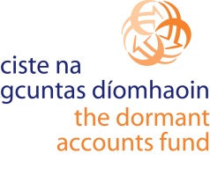
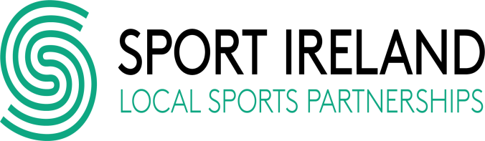
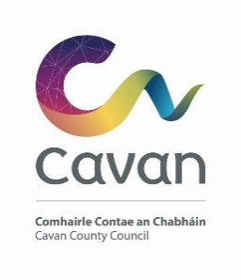
- Improved network of trained guides and leader’s information, knowledge and awareness about outdoor activity and adventure sports opportunities in disadvantaged urban areas

