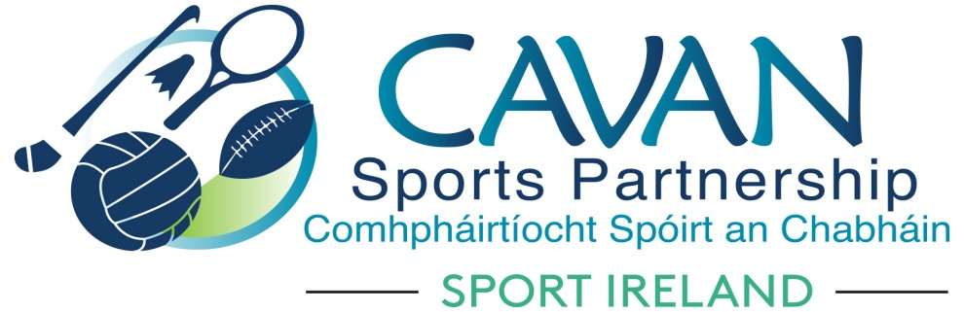

Annual Report 2017

‘Sport and activity for life, for all’
Contents

Page

Foreward ................................................................................ 3

Introduction ................................................................................ 4

CSP board & staff ................................................................................ 5

CSP Funding ................................................................................ 6

CSP vision, mission & values ................................................................... 9

Theme 1 Building participation................................................................. 11

Theme 2 Enhancing community capacity and partnerships..................... 18

Theme 3 Improving communications and marketing................................ 21

Governance ........................................................................................... 22

Conclusion ............................................................................................ 23

Foreword

On behalf of Cavan Sports Partnership, we are delighted to present this annual report, which provides an overview of the work of the Partnership in 2017.
CSP continues to be very thankful to Cavan County Council, Sport Ireland and our local partners for their continued support and investment which enables us to do our job.
Finally, CSP thanks all those who have contributed to the compilation of this annual report and also to the team of tutors who were involved in the many programmes. A special word of thanks must go to the staff of CSP who work hard to ensure we meet our strategic objectives each year.

John Kearney Nadine Mc Cormilla

Chairperson Sports Co-ordinator

Introduction
Sport Ireland (formerly The Irish Sports Council) was established in 1999 to plan, lead and coordinate the sustainable development of sport in Ireland. In its first strategic plan (2000) Sport Ireland proposed the creation of a network of Local Sports Partnerships (LSPs) as a central element in advancing its Participation Strategy. By 2008, a national network of 30 LSPs had been established, including Cavan Sports Partnership ( CSP). The key role of the Local Sports Partnerships was and is to increase participation in sport by creating sustainable structures for people to become involved at a level of their choosing, regardless of their ability, gender or background. In its latest statement of Strategy, Sport Ireland refers to the LSPs as having become a “singular success” and it is a strategic priority of Sport Ireland to ensure the LSP Network is sustained and to expand the range of sport and recreational activities made available in local communities.

On the ground, Cavan Sports Partnership operates as a substructure of Cavan County Council, guided by a Board comprised of key local stakeholders and influencers in sport and activity. The CSP and its associated staff are housed within the Community and Enterprise Section of the Council and the development of sports and activity within the county and the work of the CSP are prominent within the Local Economic and Community Plan (2016-2021). Fundamental to the operation and success of the Sports Partnership is ongoing collaboration with partners throughout the county and beyond, including local sports clubs and communities, National Governing Bodies of Sport, statutory agencies, sports providers including coaches and trainers, target group networks, volunteers and the wider community.

Who are we?

Cavan Sports Partnership Staff 2017
• Sports Coordinator; Nadine Mc Cormilla
• Sports Inclusion Development Officer; Dean Mc Elroy
• Community Sports Development Officer; Aine O Reilly
• Sports Administrator; Siobhan Donohoe / Diane Mc Enerney

The Board of Cavan Sports Partnership
An advisory board guides the work of the CSP and ensures effective implementation of the strategic plan. It is made up of those regarded as key influencers and stakeholders in local sports development and comprises of representatives of the following agencies, sporting and community organisations:
• Cavan & Monaghan ETB Breffni Integrated
• Cavan County Council Health Service Executive
• Schools representatives Public Participation Network
• Disability representative Elected representatives
• Sports Representatives Cavan Institute

Role of the Cavan Sports Partnership
CSP has a role across the sports landscape of County Cavan including:
•Supporting facilities, organisations and volunteers which make sports possible, for example sports halls, pitches, sports clubs, youth and community groups, coaches and committees.
•Enabling sports activities which appeal to people and encourage participation, to include team sports, minority sports and individual sports.
•Providing access to information on the sports activities, opportunities and organisations which enable people to structure their participation in sports.

We will undertake this role by:
- Providing meaningful Sports and Physical Activity Programmes
- Targeting Low Involvement Groups and Individuals
- Identifying Appropriate Places for Participation
- Fostering Quality Provision of Sports and Physical Activity Experiences

CSP Funding 2017
Core funding for Cavan Sports Partnership is provided by the Sport Ireland. In 2017 the SI provided €126,415 for staff and administration costs and a further €10,090 in programme funding for high priority targeted initiatives which are identified by CSP.
In addition to this Sport Ireland provided
- €25,000 toward the staff and administration costs of the Sports Inclusion Development Programme. This position is a shared post between Cavan and Monaghan local sports partnerships. Additional staff and administrative costs were provided by Cavan and Monaghan County Council.
- €35,000 toward the staff costs of the Community Sports Development Officer. Additional staff and administrative costs were provided by Cavan County Council.
- Dormant accounts funding totalling €79,213 towards the following:
- Community Coaching programme
- Kilnaleck Community Sports Hub
- Transition year sports leadership programme

CSP was further funded by the following:
- Cavan County Council as a primary source of funding through “in kind” support such as office space and administrative support. Cavan County Council also provided support funding for the Cavan Walking festival events.
- Local partners who provide both financial and “in kind” support for CSP programmes such as venues, access to coaches and supported the administration aspect of programmes.
- Additional programme funding in 2017 was awarded from the following external sources:

Cavan County Council | €20,000
Cycling Ireland | €4,000
Go for Life | €1,000
National Bike Week | €5,000
Dormant Accounts | €79,213
Waterways Ireland | €2,000
National Recreation week | €1,000
National Play Day | €650
Total | €112,863

Cavan Sports Partnership ‘Sport and activity for life, for all’ 2017-2021
Cavan Sports Partnerships third strategic plan ‘ Sport and activity for life, for all 2017-2021’ was developed and launched in 2017. This plan builds on the successes of the previous plans (Sport for life, Sport for All 2008 – 2012 and Sport for Life, Sport for All, 2013 – 2015) and has an aspiration of achieving an active county where sport and physical activity is an important part of daily life. This plan acknowledges the contribution that sport and physical activity has on not only the physical, but social and mental health of all people within our county.

Cavan Sports Partnership Vision, Mission and Values
The Vision of the Cavan Sports Partnership is very simple and reflects our determination to contribute towards improving the levels of sport and physical activity for all of the people in the county at all stages of life.

Our Vision: ‘Sport and activity for life, for all’

The Mission of the Cavan Sports Partnership is threefold:
- More activity throughout the county and more people taking part
- Support for and partnership with communities, clubs, sports providers and volunteers in the county
- Building Cavan’s sport and activity infrastructure and resource base

Cavan Sports Partnership Strategic Themes
The work of the CSP in the period 2017 to 2021 will be guided by the following three themes:
1. Building participation: continually improving the opportunities for all the people of the county to participate in sports or to be more active, with a particular focus on those with currently low participation rates.
2. Enhancing community capacity and partnerships: continually improving the human and physical resource base for sports and activity in Cavan and nurturing the relationships and collaborations which make things happen.
3. Improving Communications and Marketing: creating more awareness and understanding of the work of the CSP and consolidating its position as the information portal for sport and activity in Cavan.
The following Annual Report gives an overview of the work of Cavan Sports Partnership in 2017 under these three key strategic theme.

Theme 1: Building Participation
Continually improving the opportunities for all the people of the county to participate in sports or to be more active, with a particular focus on those with currently low participation rates.
In 2017, through its sports inclusion and community sports development programmes the sports partnership delivered 48 physical activity programmes with approximately 4296 people taking part throughout the county. The programmes targeted people from all walks of life; young people, women in our communities, people with a disability, adults aged 50 +, non Irish Nationals, primary and secondary schools, community based initiatives and mass participation events.
These programmes share the underlying goal of increasing local participation in sport. CSP aims to engage, up-skill and empower communities as part of programme development in order to ensure sustainability.
CSP offers an extensive and varied range of programmes. Some projects are mass participation events and attract many hundreds of participants, for example the Cavan Walking Festival and Community Transformation. There are also short term programmes which provide opportunities for people to engage in new sports and activities, for example Couch to 5k. Other programmes aimed at marginalised groups are more focused and targeted. Older Adults programmes have continued to expand and new activity classes and ways to engage older adult communities were introduced in 2017. Older adult and programmes for people with a disability are delivered through the Sports inclusion programme funded by Sport Ireland, Cavan County Council and Monaghan County Council.
The schools programme calendar has expanded in 2017 with the involvement of five National Governing Bodies of sport supporting the opportunity for schools to engage in new sports. Schools and community based programmes are delivered through the community sports development programme funded by Sport Ireland and Cavan County Council.

Cavan Sports Partnership participation initiatives delivered in 2017
Community based initiatives
Programme | Target Group | No. of Participants | Partners
Operation Transformation  National Walk | Communities of Cootehill, Kilnaleck & Virginia | 380 | RTE Operation Transformation  Area committees
Community Transformation | Communities of Cootehill, Kilnaleck & Virginia | 355 | - Community Transformation committees in each area.
Workplace Operation Transformation | Cavan County Council employees | 60
Workplace Wellbeing | Cavan County Council and Dept of Agri. | 49
Get Ireland Walking | Kilnaleck Community | 13 | Womens group
Buggy Brigade | Inactive mothers | 18
Couch to 5k | General population | 190 | Annalee AC  Gowna GAA  Lavey GAA  Belturbet GAA  Cootehill Community  Corlough GAA
National Bike week 2017 | General population | 600 | Local cycling clubs and community groups
 | Total community participants | 1665
Primary and Secondary schools initiatives
Programme | Target Group | No. of Participants | Partners
Off Road Biking | TY students | 78 | Cycling Ireland  Cavan Canoe Centre  Virginia College  Bailieborough Community School
Active Teens | Secondary School girls | 102 | St. Aidans Cootehill, Colaiste Dun a Ri, Bailieborough Community School
Paddles Up programme | TY students | 60 | Waterways Ireland  Cavan Canoe Centre
 | Total secondary school participants | 240
Tri-Heroes | Schools | 355 | Primary Schools  Secondary Schools  Triathlon Ireland
The Daily Mile | Primary school pupils | 1600 (approx) | Primary schools
Tug of War programme | 3rd and 4th Class pupils | 250 | Irish Tug of War Association
Tug of War Blitz | 3rd and 4th Class pupils | 91 | Irish Tug of War Association
 | Total primary school participants | 2296

Sports Inclusion participation initiatives 2017
Active Adults 50+ initiatives
Programme | Target Group | Number of Participants | Partners
Gentle Pilates | Active Adults 50+ | 118 | ICA and Active retirement
Chair Based Exercise | Active Adults 50+ | 86 | ICA and Cootehill Happy Feet
Adapted Aerobics | Active Adults 50+ | 143 | ICA,Active retirement, Cavan Gaels GAA
Gentle Yoga | Active Adults 50+ | 29 | ICA and Active retirement
Ladies Golf | Active Adults 50+ | 13 | Cavan Golf Club
Go For Life Games | Active Adults 50+ | 12
Line Dancing | Active Adults 50+ | 29 | ICA Group
Zumba Gold | Active Adults 50+ | 36 | ICA and Active retirement
Pitch and Putt | Active Adults 50+ | 6 | ICA and Active retirement
New Age Kurling | Active Adults 50+ | 12 | ICA and Active retirement
Sportsfests | Active Adults 50+ | 57 | FAI/Ballinagh Walking Group
 | Total Active Adults 50+ participants | 541
Disability participation initiatives
G.A.A Skills | Sports Inclusion Adults | 30 | Cavan G.A.A/Disability Services
Sitting Volleyball | Sports Inclusion Adults | 44 | Disability Services
Easter Jamboree | Sports Inclusion Adults | 49 | Disability Services,Badminton Ireland, Cavan Lakers Basketball, Scouts
Inclusive Cycling | Sports Inclusion Children | 14 | Tanagh OEC
Soccer Skills | Sports Inclusion Adults | 41 | FAI
Outdoor Bowls | Sports Inclusion Adults | 21 | Outdoor bowling Committee
Exercise to Music | Sports Inclusion Adults | 12 | Rehabcare Cavan
Enjoy Tennis | Sports Inclusion Adults | 16 | Cavan Tennis Club
Tag Rugby | Sports Inclusion Adults | 27 | Cavan Rugby Club
Badminton Taster | Sports Inclusion Adults | 19 | IWA Cavan/Badminton Ireland
Walk,Jog,Run | Sports Inclusion Adults | 42 | Disability Services
FAI Camp | Sports Inclusion Children | 11 | FAI
G.A.A Camp | Sports Inclusion Children | 13 | G.A.A
Inclusive Multi-Camp | Sports Inclusion Children | 23 | Peace Link
Intro to Water | Sports Inclusion Children | 8 | Cavan Leisure Centre
Xcessible Tag Rugby | Sports Inclusion Children | 42 | Virginia RFC
Inclusive Gymnastics | Sports Inclusion Children | 15 | Breffni Gymnastics  Academy
 | Total sports inclusion participants | 427

Theme 2 : Enhancing community capacity and partnerships
Enhancing community capacity and partnerships: continually improving the human and physical resource base for sports and activity in Cavan and nurturing the relationships and collaborations which make things happen.
Cavan sports partnership delivered a number of subsidised training courses to club coaches, volunteers, schools and community groups throughout 2017 including:
Course name | No. of courses delivered | No. of participants
Safeguarding 1 | 7 | 96
Safeguarding 2 | 3 | 33
Safeguarding 3 | 1 | 17
Disability awareness in sport | 2 | 37
Games for all – inclusion training | 6 | 134
Get Ireland Walking | 1 | 13
Youth Sports Leader | 2 | 53
Rounders Teacher training | 1 | 10
Seminars | 3 | 21
Disability Awareness Training | 4 | 37
Total | 30 | 451

National Governing Bodies; we work with NGB’s to develop sports specific programmes. In 2017 we worked with the FAI, GAA , Ulster Rugby, Triathlon Ireland, Volleyball Ireland, Athletics Ireland, Tug of War Association of Ireland, Tennis Ireland, Cycling Ireland and Waterways Ireland.
CSP Grants; An allocation of €5,300 was disseminated to sports clubs and community groups towards sports mass participation events and equipment. The aim of the grant scheme was to support club coaches and volunteers through training, education and equipment grants to resource and strengthen the club. A mass participation scheme also afforded both clubs and community groups the opportunity to gain financial support towards a community based sporting event.
2017 small grant recipients
Club | Amount Awarded
Community Mass Participation
Killinkere Gaelic Football Club | €500
Coach Education
County Cavan RFC  Annalee AC  Breffni Blues Special Olympics  Cavan Tennis & Padel Club  Cavan Wrestling Club | € 300  € 300  € 300  € 300  € 300
Equipment
Kingscourt Harps AFC  Cavan Chess Club  Cavan Lakers Basketball Club  Silver Fins Special Abilities Swim Club  Cavan Kendo Kai  Cavan Hockey Club  East Cavan Swim Club  Denn Camoige Club  Cuilcagh Triathlon Club  Butlersbridge Running Club  Ballyjamesduff Gun Club  Drumgoon Camoige Club  Milltown Badminton Club | €200  €200  €300  €300  €100  €300  €300  €200  €300  €300  €300  €200  €300
Total | €5,300

Theme 3: Improving communications and marketing
Creating more awareness and understanding of the work of the CSP and consolidating its position as the information portal for sport and activity in Cavan.
Cavan Sports Networking
The first Cavan sports networking event was held in November 2017 with the aim of bringing representatives from the National governing bodies of sport and local sports clubs together.
Strengthening our work on social media platforms
CSP focused on the development of our social media presence in 2017, using facebook successfully to increase numbers on our programmes and create awareness of our work throughout the county and beyond. CSP facebook page is also used as a tool to promote other sports clubs and communities events. The online mail forum www.mailchimp.com was used to develop online newsletter / e-shot’s in 2017. This mechanism was more efficient with up to date material and little cost to produce. There was a direct correlation in the publishing of the e-shot and sign up to courses and programmes through the online Eventbrite booking system.
CSP piloted the use of www.eventbrite.ie as a platform for course bookings. The forum proved successful, eliminating some of the administration work behind the running of the course and allowing participants to pay for their course prior to attendance.
There was no hard copy CSP newsletter produced in 2017.
CSP training calendar: CSP developed a training calendar with all available courses for 2017.

Governance

In 2017 there was continued active participation of relevant agencies and partners on the CSP Board
- 4 meetings of CSP Board occurred in 2017

Two sub-committee’s were formed and reported work to CSP Board;

Grant sub committee
- Strategic plan sub committee

Administrative and Financial Management:
Secure and manage the resources of the CSP in a transparent manner
- CSP inputs its data into the Sport Ireland national monitoring and evaluation tool – SPEAK (strategic planning, evaluation and knowledge)
- Bi annual financial reporting to Sport Ireland.
- Quarterly financial reporting to the board of the sports partnership.
- Internal auditing through Cavan County Council finance department.

Memberships:
- Federation of Irish Sport (FIS): CSP continued its annual membership of the Federation which advocates for sport at a national level.
- CSP is also represented on a number of local committees ;
  - Cavan Age Friendly society, Cavan disability network, Cavan & Monaghan healthy families, Healthy Cavan, Healthy Cavan at your library, ‘Right to read’ Cavan.

Conclusion
The investment both nationally and locally in both the community sports development officer and sports inclusion development officer has proved successful for participation in local communities, adults over 50+, people with disabilities and schools throughout the county. These dedicated resources have allowed the development of relationships and networks which in turn has strengthened community capacity to sustain physical activity programmes locally.
The sports inclusion development officer position is part time, covering counties Cavan and Monaghan. Given the growth in programme participation, growth within our active aging population and demand for activities there is merit is looking ahead to securing funding to expand this programme to a full time position to meet the needs within our county.
The partnership working between CSP and the National Governing Bodies of Sport (NGB’s) to provide participation opportunities within our schools and disability sports programmes in 2017 was an excellent example of how a LSP can support the national implementation of a local sport.
The welcomed announcement of dormant accounts funding in December 2017 towards Cavans first community sports hub presents an exciting opportunity for sustainable sports development at a community level.
It is our responsibility to identify gaps in our provision and areas of improvement going forward. With this in mind we are cognisant of the fact that a small minority of our work takes place in the west Cavan area. In order to implement meaningful sports development practice in the area a staffing resource needs to be allocated. This will allow consultation and the development of local networks to support physical activity participation.
We will aim to focus more on CSP’s marketing and communications in 2018 while further implementing our strategic actions.

‘Sport and Activity for life, for all 2017 – 2021’

.
Appendix 1 Participation initiatives and map of location of initiatives

Community & Schools programmes

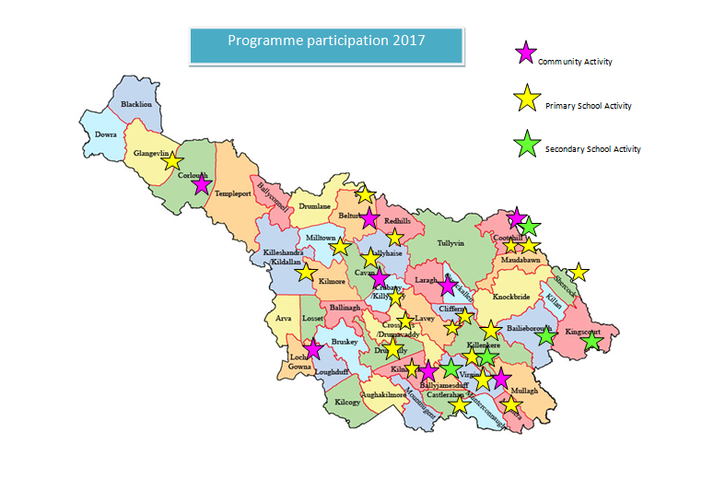

Disability and Active Adults 50+ programmes
