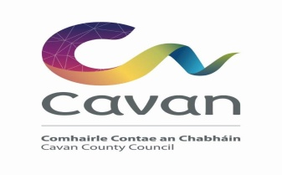
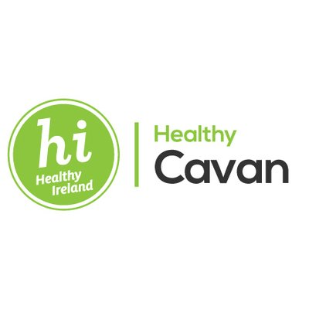
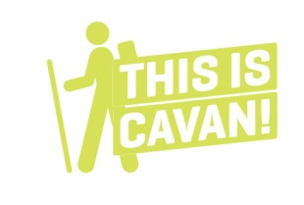
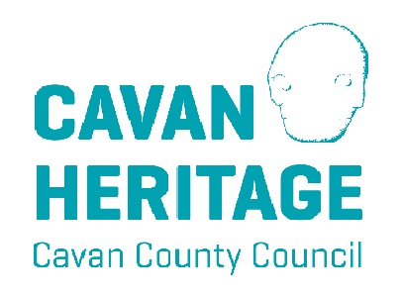
This is Cavan –
Walking Festival 2018
May 4th – 11th
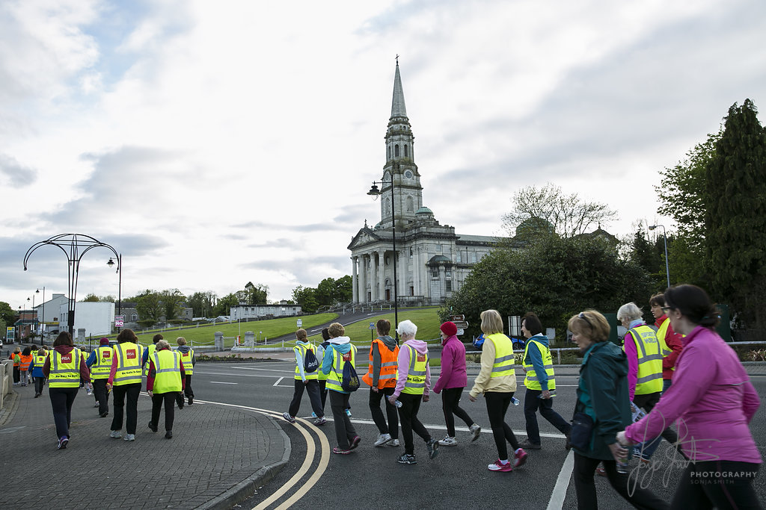
For the 8th consecutive year, Cavan hosts the annual Walking Festival, attracting walkers from all over Ireland to take in the beautiful scenery and landscapes of county Cavan. This year the event extended over an 8 day period with 19 walks organised by the Cavan Walking Festival committee and community groups. The walkers all delightfully basked in the beautiful sunshine that beamed down on the fascinating walking trails and glistening lakes alongside the walkers. This 8th annual festival introduced some new walking trails while also retaining some of the old favourites.
There were walks available for all walkers, a gentle stroll for the elderly and families, moderate forest trails for the enthusiasts and the more experienced walkers could enjoy a brisk hike across mountainous Cavan countryside. All walks were led by an experienced leader who could express historical facts about the land and scenery the walkers observed throughout the county. The ‘This is Cavan Walking Festival’ took place over the May bank holiday weekend and continued throughout the week finishing on Friday 11th May with a beautiful Heritage walk in Arva.
There were four different categories to choose from ‘Walk a little longer’, ‘Walk Cavan’, ‘Cavan Heritage Office Golden Ways’ and ‘Walk Geopark’. The ‘Walk a little longer’ trails ranged from 10-13km with brisk walkers enjoying breathtaking scenes. The ‘Walk Cavan’ category involved 5km walks with a trail each day in a different area of the county, these walks invited families and the elderly for some gentle and moderate walks with shallow steps and gentle slopes. The Heritage Office offered walkers the opportunity to walk a 3-6km distance while also being historically educated on the wonderfully built, natural and cultural heritage throughout the county. And the fourth category ‘Walk Geopark’ entailed walking trails from 4-13km located in the the beautiful Geopark containing a variety of mountainous, historical, archaeological and culturally rich sites with amazing walking routes.
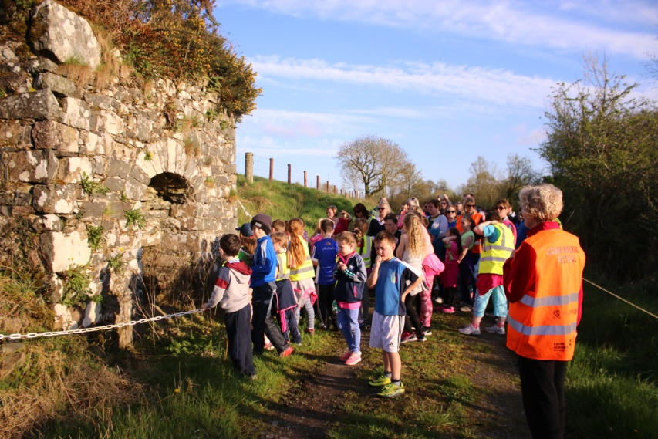
This is Cavan – Walking Festival kicked off on Friday 4th May with a scenic Cavan Burren Park walk (A Prehistoric Park) organised by the delightful Cavan Geopark. This limestone karst landscape was an excellent route to kick-start the week of walking. Many walkers embraced the limestone region to enjoy the warm weather in the Burren Park. It was a magical scene and all the walkers were thoroughly pleased with this event but for some, they were only getting started.
Over in Crossreagh the Heritage Office organised the Hollow Lane Golden Way walk specialised for people with young families and the older community to enjoy a gentle 3km scenic walk. Illustration 1: Golden Way Walk

Heather Bothwell, an ecologist and wildlife enthusiast and Aidan Brady, a member of the Cavan Bee Keepers were accompanying the huge number of 84 walkers on this route. They were there to assist any inexperienced walkers and to speak about the beautiful history and to discover more about nature. The Golden Way walk was great for children as there were lots of history education they could learn about. Children were fascinated by the wildlife experts and now have new knowledge on the wildlife in county Cavan.

Saturday morning in West Cavan, walking groups and enthusiastic walkers all gathered in Blacklion to take on the challenging Cavan Way – Dowra to Shannon Pot hike. 65 advanced walkers trekked 13 kilometres from Dowra to Blacklion finishing at the Shannon Pot. Along the mountainous trail they enjoyed some old Irish mythological stories and it proved to be a truly sociable event with walking clubs sharing routes and experiences as they joined in on community spirit. An ideal opportunity for those who had never experienced the Burren Park as they walk through this region before descending into the village of Blacklion taking in the stunning landscapes of county Cavan and the local limestone karst regions available to the locals within reach.
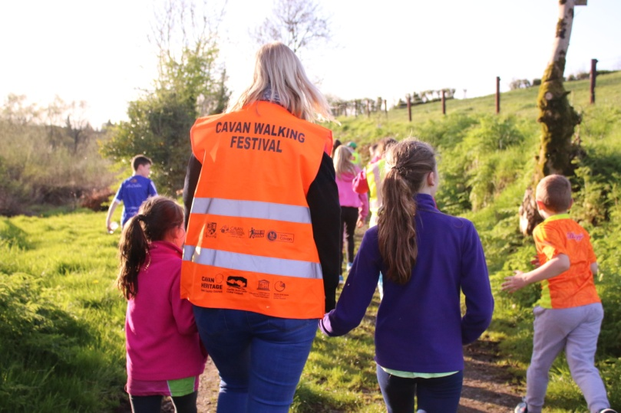
Meanwhile, a less strenuous 5km walk was held in Bailieborough, organised by the Bailieborough Walking Group. Nature enthusiasts observed the panoramic views of the tranquil forest and surrounding lakes while enjoying the slow rhythm of the outdoors. With the sun beaming down walkers strolled at their ease and thoroughly enjoyed the experience.
Sunday morning, saw the advanced trekkers rose again to complete the magical Cavan Way – Shannon Pot to Blacklion walk. Most of the hikers completed the split 26km walk on both Saturday and Sunday while some partook in just the Sunday event. This is an introductory walk that has never been completed before therefore bringing it to the Walking Festival was an honour held by Cavan County Council.
On the same afternoon Hollow Lane in Cross hosted a 6k family fun walk inviting the whole family for the whole family to participate. The walk was suitable for youngsters to run ahead and have fun with some surprises on route. Shallow steps were suitable for off-road buggies and it was a calm setting for the family to enjoy the peaceful route. An amazing adventure for the little ones as the rain held off and they could enjoy the sunshine while also exercising their legs with the company of their parents and families.
Bank holiday Monday by no means slowed our walkers down as they joined walks in Ballyconnell and Virginia. A beautiful woodland river walk hosted by Cavan Geopark proved to be a popular choice providing a scenic trail that walkers could experience at their own pace as they observed archaeological sites, castle ruins and beautiful, tranquil landscapes Later that evening, the Virginia Ramblers organised a brisk Deerpark Forest Heritage Walk. Walkers followed tree-lined paths in the Deerpark woodland, passing some beautiful scenes of the banks of Lough Ramor and blooming flowers in the forest. 46 people joined in on this forest walk and enjoyed the cool evening and the bright evening beaming down upon them.
Tuesday evening in the northwest of Cavan in the green land of Bawnboy the Heritage office the Jampa Ling Golden Way walk commenced for another year, a 5km walk including soothing meditations and a slow –paced walk to enjoy the surrounding area. The area surroundings is a place for extreme relaxation and retreat. The walkers strolled down the beautiful woodlands in Jampa Ling and immersed themselves in the relaxing meditation.
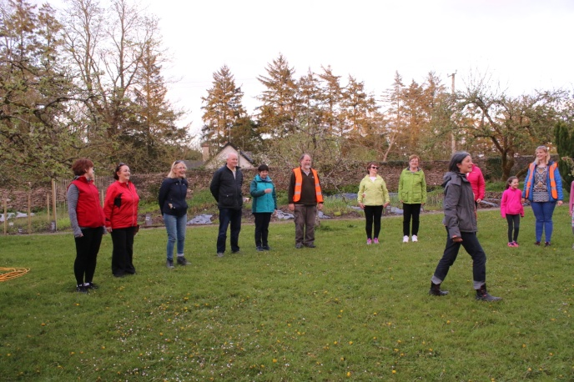
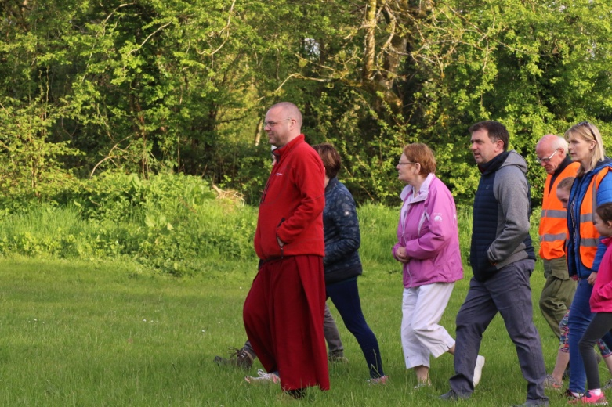

Illustration 3 & 4: Jampa Ling Golden Way
In a more vibrant, abrupt setting the Bailieborough Walking group joined by 33 walkers, took out their hiking boots again and headed to Dun-A-Rí forest park. Walkers endeavoured the beautiful forest trails of Dun-A-Rí in a more fast-paced walk as they joined together to enjoy the stunning landscapes while also getting their hearts racing.
This Tuesday evening also welcomed the Cavan Strollers to the festival hosting a first time Cavan Town Walk meeting at the Orchard along with 47 eager walkers. Those who joined and had an interest in local history were in for a treat as they were guided around Cavan Town in areas that are long forgotten, bringing back some culture to the local community.
Midweek was by no means a slump, as three walks commenced at 7pm. Happy Feet Walkers were in top form as they paced 10k and 5k forest walks, giving the more experienced walkers the chance of fleeting ahead where the more slow paced walkers were able to enjoy the landscapes on the 5k route. Munterconnaght Heritage office also hosted a 5k Baherna/Reyfield Loop Walk which encircles the ‘Old boat road golden way’ with natural and built heritage along the route followed by inspiring words given by the leader.

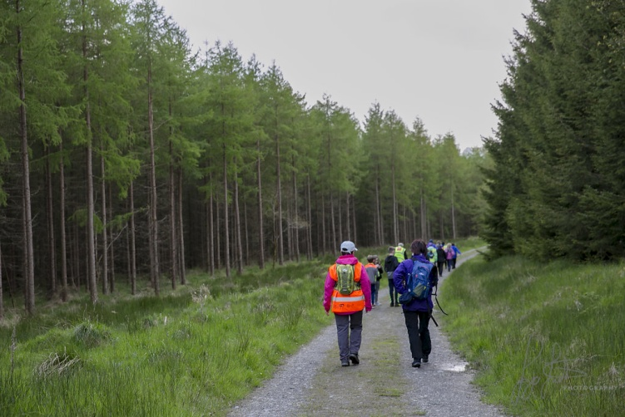
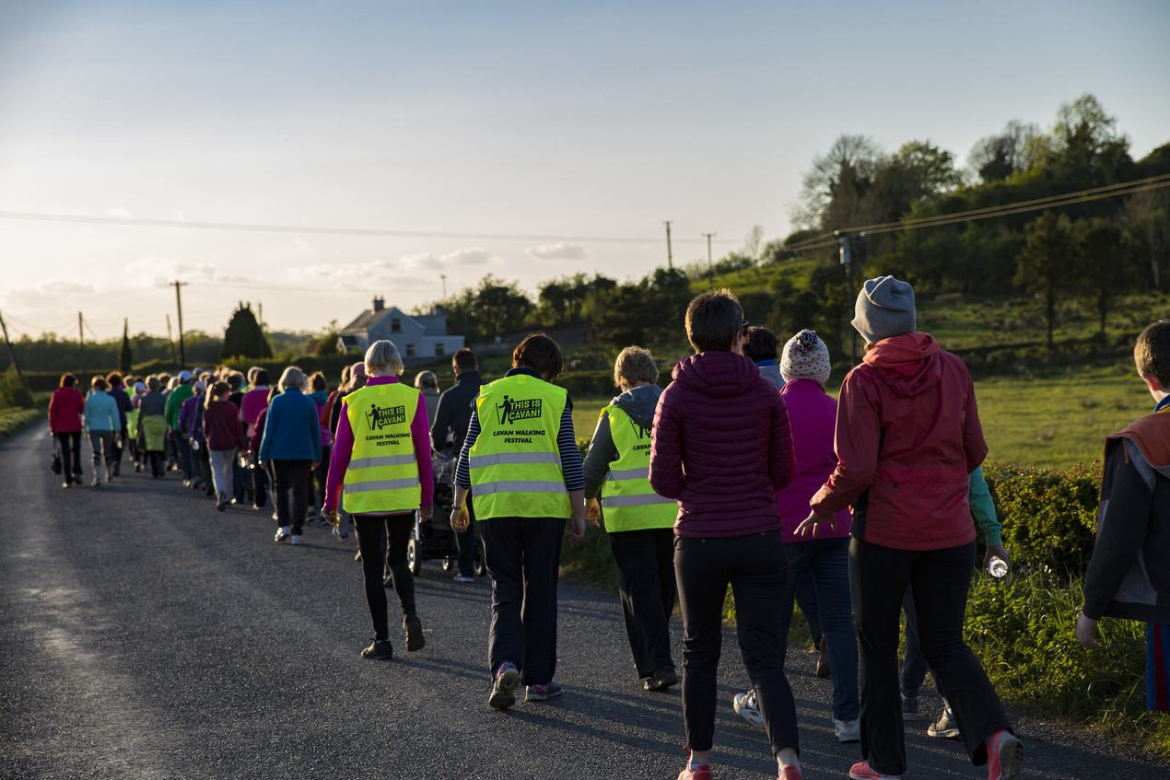
Back in Bailieborough on a beautiful Thursday evening, 70 walkers raised their heart rates and got their blood pumping on a moderate walk by the forest trail of Lough an Leagh. A magical fairy fort was at the eye line of participants and visited by the oncoming walkers. The bright, flawless summers evening meant the famous Cuilcagh Mountain could be seen on a mountainous hilltop in Bailieborough, a breathtaking experience. In West Cavan the Geopark, hosted a gentle 6k walk the Garvagh Lough Loop. This walk was made available to many to capture the stunning lake of Garvagh which is located on a limestone bed of rock. The bright sun casted down on the lake giving it a fantastic hue that all walkers could admire. At the same time the ever so popular Cloverhill/Keeney walk organised by the Cavan Strollers set off at 7pm with over 90 people taking part. A peaceful accessible walk finished in style with refreshments courtesy of the Olde Post Inn and some cultural Irish music.
On the final day of the 2018 Cavan Walking Festival, walkers once again joined the Geopark for the ‘Moneygashel – A walk through time’. Walkers who attended this 4k walk viewed the prehistoric walls and ruins that can still be seen from centuries before. An ideal walk for people to enjoy learning about the history of their local area and explore the historical landscape.
The finishing event was the stunning walk, the Brankill Golden Way Bat Walk. Held at dusk, nature enthusiasts explored the bats in their natural setting while embracing a fresh evening stroll.
Overall, This is Cavan – Walking Festival 2018 was a huge success with over 800 enthusiastic walkers coming to join in on the community spirit and enjoy the beautiful Cavan landscape. Cavan was luckily blessed with the fantastic weather inviting hundreds of walkers to take on the stunning routes each day.

Evaluation
After each individual walk participants were asked to fill out an evaluation form on their walking experience. An online survey was also conducted to assess the walkers that may not have gotten the chance to fill out the form on the day of the event. These evaluations are aimed to assist the work of the Walking Festival committee and to identify improvements that could be made for next year and to view the success of what had already happened.
The festival was a brilliant success with over 800 people participating in the 19 glorious walks that were organised for the Walking Festival. 40% of these participants responded to the evaluations. Some walking groups hosted walks in their local area as they would know the area well and which routes were available to take, the heritage office also organised some walks bringing the local community together to view the cultural heritage and beautiful scenes in the stunning Cavan landscape. A big highlight of the festival was the two-day 26k hike with over 50 people participating in the two days with 13k each day. The Cavan Strollers walking club succeeded in bringing in over 90 enthusiastic walkers for the Cloverhill/Keeney walk.
Majority of the people involved in the walks didn’t travel from outside of Cavan or if they did most people didn’t stay over. The people who stayed in county Cavan mostly stayed with family and if not then the other accommodation taken was the guesthouses throughout the county.
In the evaluation the participants were asked what age category they were part of; 86% of the participants were in the 50+ category, 13% of respondents fell into the 25-50 category, leaving only 1% of the population in the 18-25 category (See Fig. 3)
Another part of the evaluation, the respondents were asked where they heard about the walking festival and were giving a number of different sources, the highest being 34% hearing about it from word of mouth, 18% heard about the festival from the local newspaper the Anglo Celt, another 18% heard about it from fellow family and friends, 12% stated by flyers and posters around the county, 9% by the Cavan Sports Partnership website, and 9% said social media (See Fig. 2)
Respondents were also asked to rate their walking experience including; walking routes available, the knowledge about the walks from the leaders, the communication from the organisers before the event, and the variety of walks on offer. Overall the feedback was excellent with; 50% stating that the knowledge that the walking leaders had was excellent, 46% said that the communication from the organisers was excellent, 46% also said that the walking routes available were excellent and 44% said that the variety of routes were excellent (See Fig. 3)
Recommendations from Participants:
- More advertising should be made locally and nationally.
- The walkers should be given yellow reflective jackets for evening walks.
- Introduce something to attract the children to join the walks.
- Make sure walking route is cleaned prior to the walk.
- Include more scenic routes.
Going forward:
- Participants of the Walking Festival were predominantly over 50 years of age.
- Majority of walkers were from local walking clubs and local areas.
- There were more women than men involved in the walking festival.

Appendix

Fig.1

Fig.2

Fig. 3

