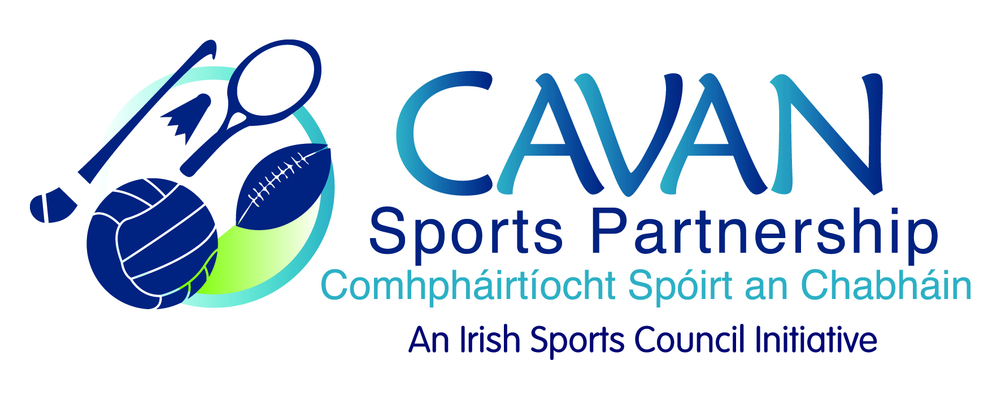

Grant Guidelines 2017/2018

The aim of Cavan Sports Partnership is to increase participation in sport and physical activity among all persons in County Cavan. Cavan Sports Partnership is looking to support initiatives by sports and physical activity clubs in Cavan who are working towards this aim.
Cavan sports partnership wish to invite applications for their sport and physical activity grant scheme for 2017/2018.

Applicants may apply under ONE of below schemes.

Scheme 1 | Club Coaching
Who can apply? | Sports and Physical Activity Clubs
What can be applied for? | - Coaching development  - Up skilling of new coaches  - Coaching courses must be NGB recognised.
Funding available: | Grants up to a maximum of €300 can be applied for towards coach education
Funding must be spent and receipts submitted to CSP by June 1st 2018

Scheme 2 | Club Equipment
Who can apply? | Minority sports and Physical Activity Clubs
What can be applied for? | - Sports equipment
Funding available: | Grants up to a maximum of €300 can be applied for towards club equipment.
Funding must be spent and receipts submitted to CSP by December 10th 2017

Scheme 3 | Community Mass Participation
Who can apply? | Sports and Physical Activity Clubs and Community Groups
What can be applied for? | (*event must attract a minimum of 300 participants)  - Community mass participation events  - Operation transformation walks 2018  - Park Run Support (new applicants)  - Community transformation areas 2018
Funding available: | Grants from a minimum of €200 up to a maximum of €1000 can be applied for under this scheme
Funding must be spent and receipts submitted to CSP by August 20th 2018

* CSP target groups include Older Adults; Women; Teenage Girls; Disadvantaged Communities; People with Disabilities.
*CSP will not award grants for the following: capital costs; annual operation costs such as insurance, registration, affiliation fees etc.
*CSP will not award grants to: statutory agencies; for profit organisations; private facility owners

Cavan Sports Partnership Grant Scheme will be subject to the following terms and conditions:

- Clubs must be affiliated to their National Governing Body of Sport where such an NGB exists;
- Clubs must operate under the basis of best practice for children in sport – a member of the club must have previously attended a Child Welfare & Protection Awareness course (new clubs must commit to attending training where appropriate)
- The funding must be used for the purpose outlined.
- Feedback must be provided to CSP in terms of objectives achieved and numbers of participants, both national and local with evidence (photos, press release) that the event has taken place.
- Provide invoices/receipts showing expenditure**.
- CSP must be branded on all promotional materials. Please note banners etc. can be provided from CSP.
- Events must ensure that there is medical cover at all times and all events are covered by their insurance (a copy of which must be supplied prior to the event).
- If successful in your application the club must agree to send at least two representatives to a grant presentation evening.
- The CSP board decision on all successful applicants is final.
- Community Transformation areas 2018: areas delivering on community transformation can apply for programme delivery support. Maximum funding per area is €150.
- Clubs/communities can apply under only one scheme per annum.
** Funding will only be made available to successful applicants after receipt of invoices
** Deadlines for drawdown of funding must be adhered to. Failure to comply with deadline may result in loss of grant.

Applications will be evaluated on the ability to display the following:
- Emphasis on participation rather than competition.
- Capacity of the applicant to promote the event.
- Show ability to provide for Cavan Sports Partnership target groups to participate: Older Adults; Women; Teenage Girls; Disadvantaged Communities; People with Disabilities.
- Numbers participating.
- Ability to generate own funds to support programme / event.
- Applicants applying under the club equipment scheme must outline their minority sport status.
Please note: There is no guarantee of funding of events / programmes which achieve the minimum eligibility criteria. The fund is limited and eligible applications will be evaluated on a competitive basis against the criteria being applied. The decision of the grant subcommittee is final.

Closing Date for Applications is Thursday 19th October at 3pm.

